Date-30/09/2023

Roll No. - 13

Expt. No. - 10

K.M.S.P. Mandal’s

Sant Rawool Maharaj Mavidyalaya, Kudal

**Department of Computer Science**

Signature

Web Browser Forensics - Analyze browser artifacts, including history files, bookmarks, and download records & Analyze cache and cookies data to reconstruct user-browsing history and identify visited websites or online activities.

Title - _______________________________________________________

_______________________________________________________

* **Web Browser Forensics:**

Browser forensics refers to the process of collecting, analyzing, and interpreting digital evidence found in web browsers. This can include information such as web browsing history, cached files, cookies, and browser extensions.  
  
One of the most common uses of browser forensics is in criminal investigations, where it can be used to gather evidence of internet-based crimes such as cyberstalking, online fraud, and child pornography. It can also be used in civil litigation to uncover evidence of employee misconduct or intellectual property theft.  
  
To perform browser forensics, investigators will typically use specialized software tools that can extract data from web browsers and analyze it for relevant information. This can include forensic software that can recover deleted files, as well as tools that can parse web browsing history and extract information about visited websites and their associated data.  
  
Browser forensics can be a complex and time-consuming process, as it may be necessary to analyze data from multiple browsers and devices. However, with the right tools and expertise, it can provide valuable insights that can help to identify suspects, uncover evidence, and build a stronger case.  
  
In addition to criminal and civil investigations, browser forensics can also be used for internal investigations, such as monitoring employee internet usage for compliance or security purposes.  
  
It is important to note that browser forensics is not only limited to the traditional web browsers but also to mobile apps. Mobile apps are becoming more prevalent in the digital age, and they often store data in the same or similar ways as web browsers. This data can also be used to track an individual's online activity.  
  
In conclusion, browser forensics is a powerful tool for gathering digital evidence and uncovering insights that can be used in criminal and civil investigations, as well as internal investigations. With the right tools and expertise, investigators can extract and analyze data from web browsers and mobile apps to identify suspects, uncover evidence, and build a stronger case.

**Open Some Websites**

**INSTAGRAM**

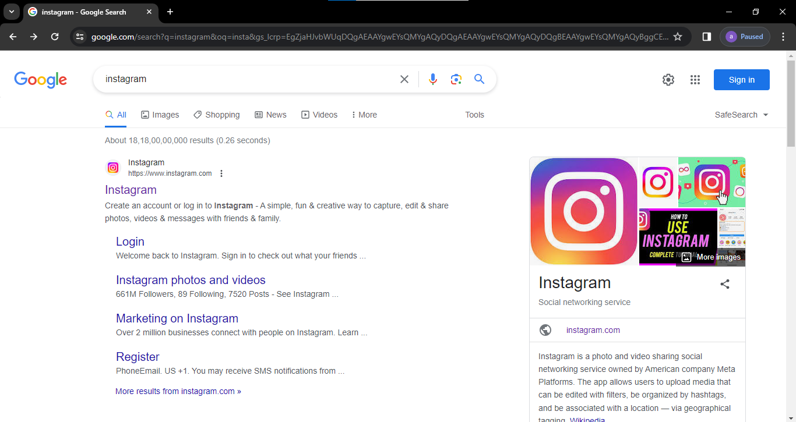

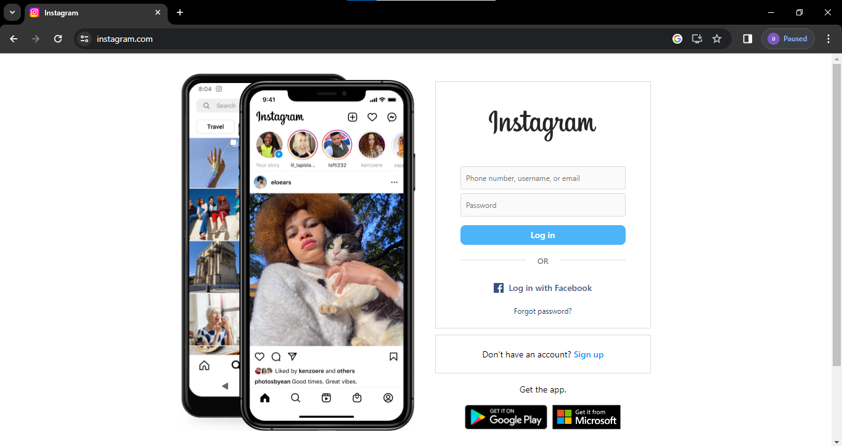

**FIGMA**

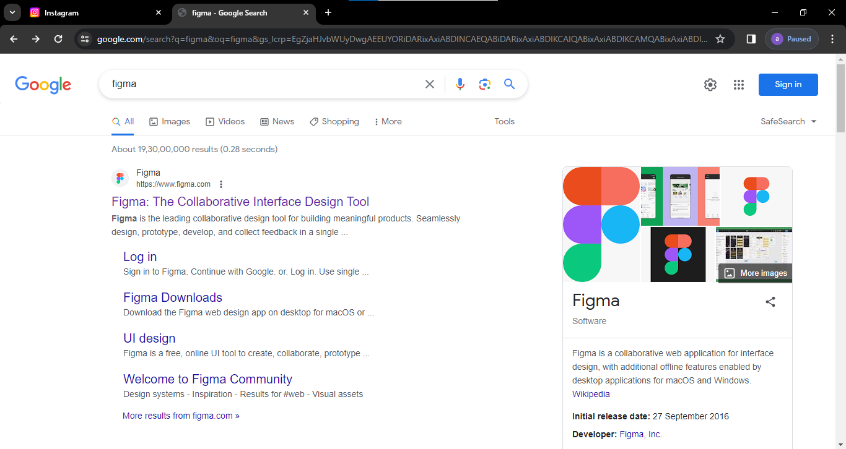



**TICKET BOOKING**

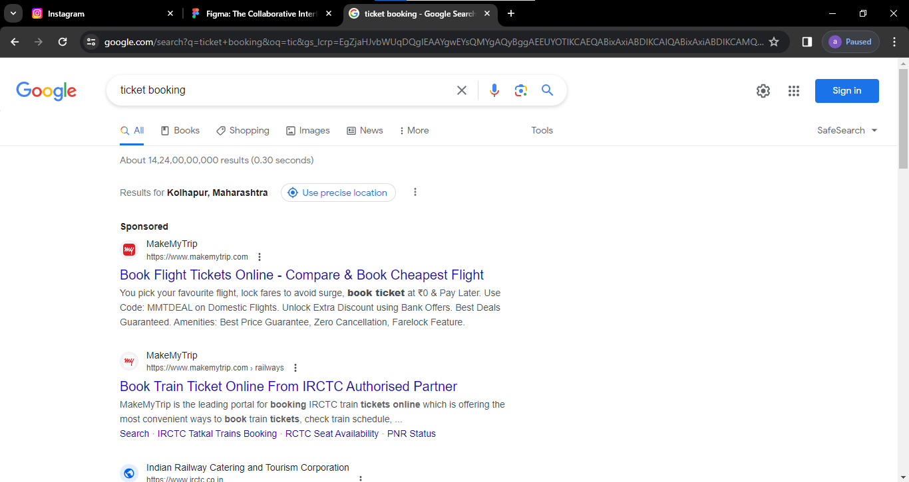



**ICC WORLD-CUP**

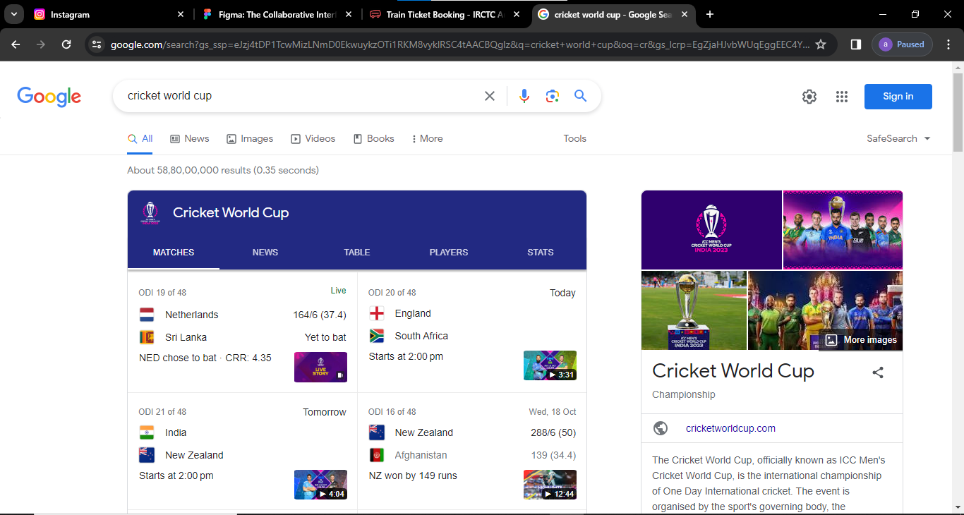



**Capturing Data**

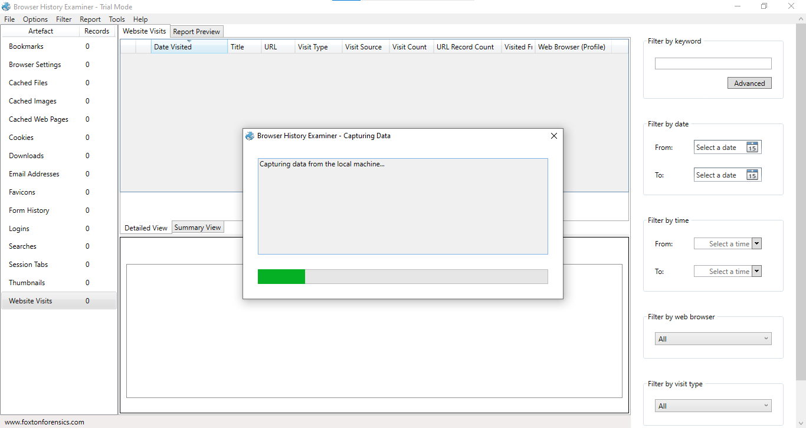

Capture History

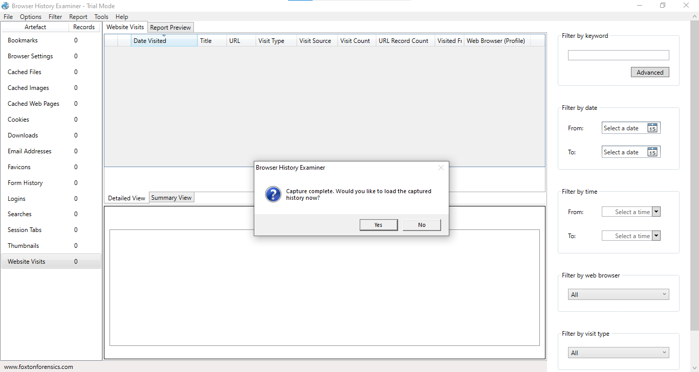

Extracting data

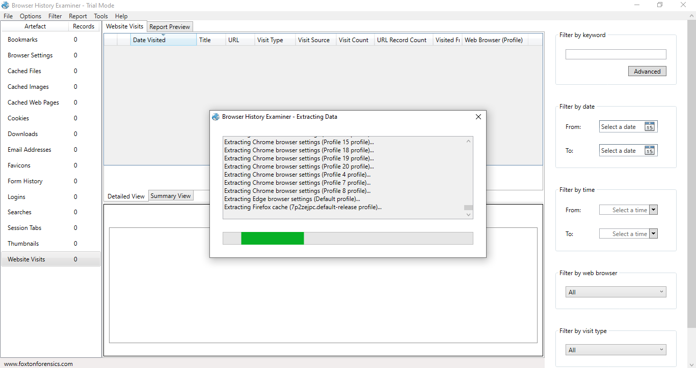

Websites Visit

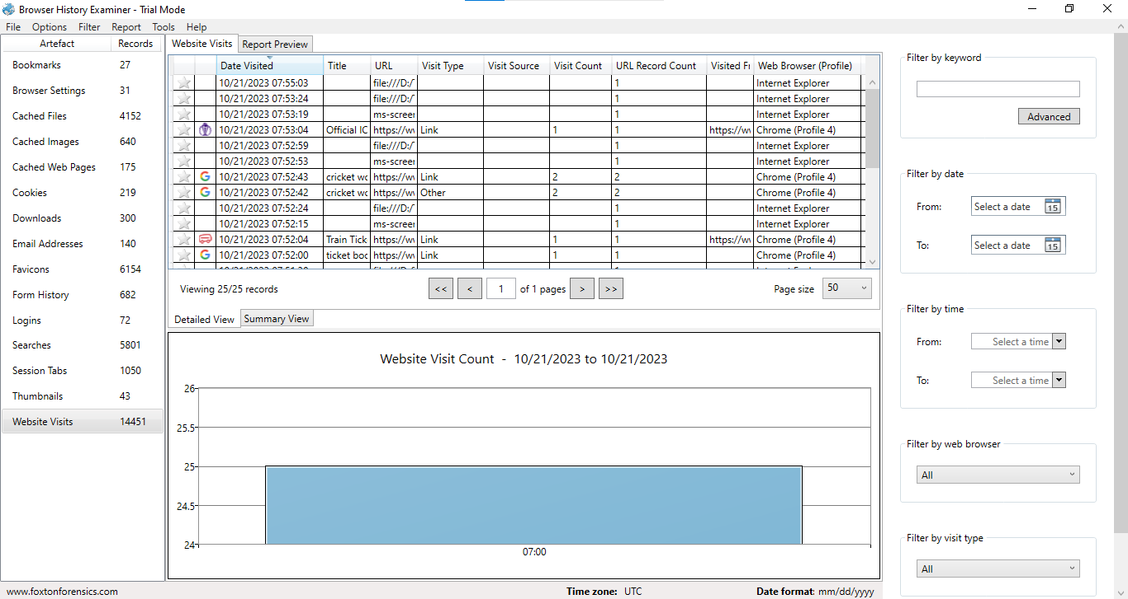

Bookmarks

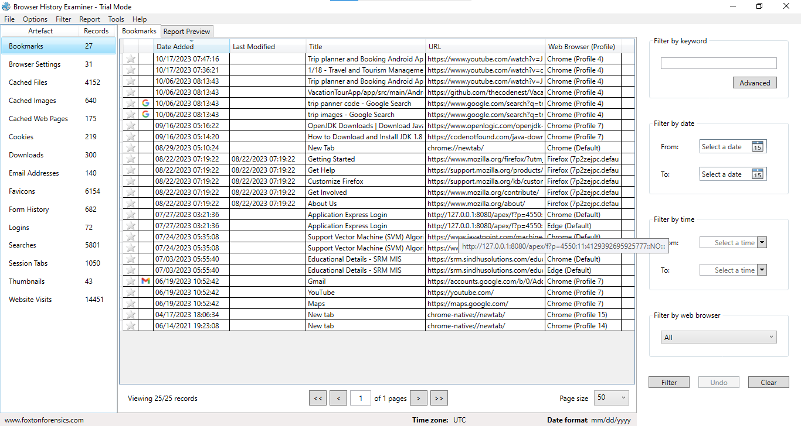

Cached Files

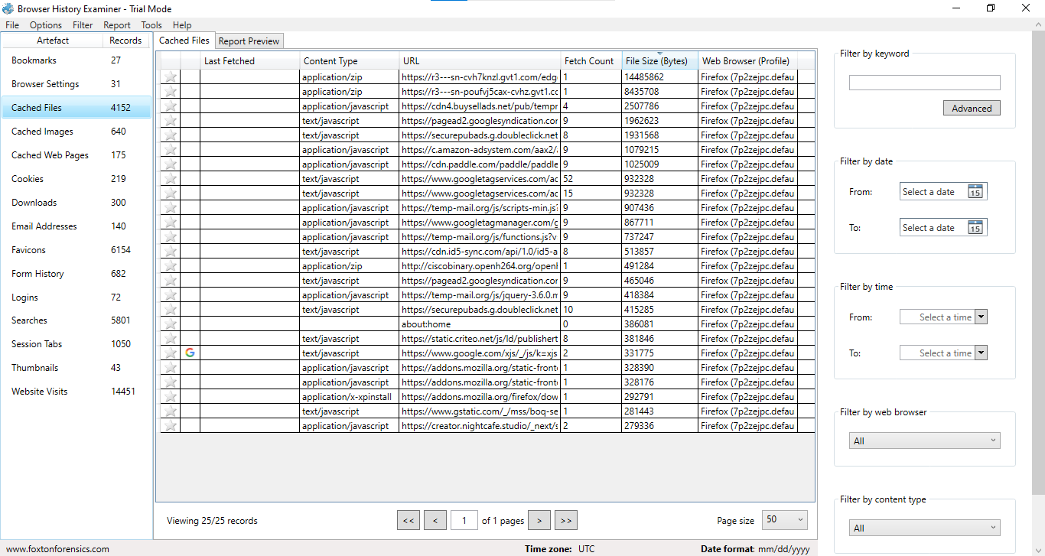

Cached Image

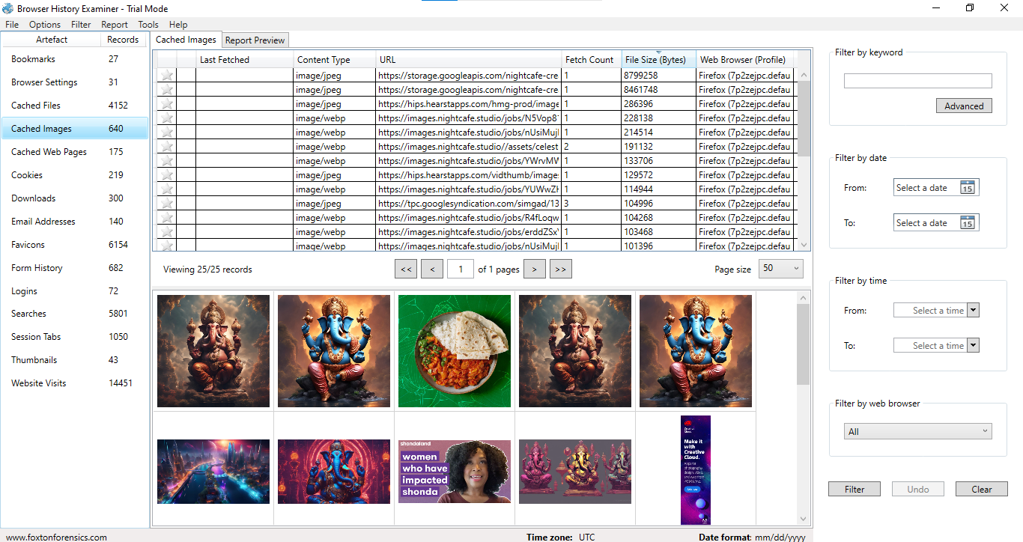

Cached Web Page

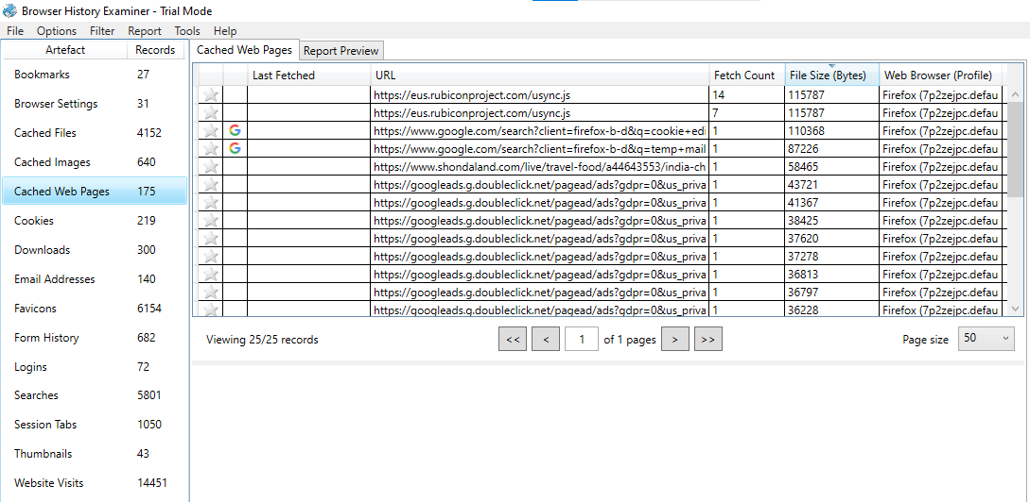

Cookies

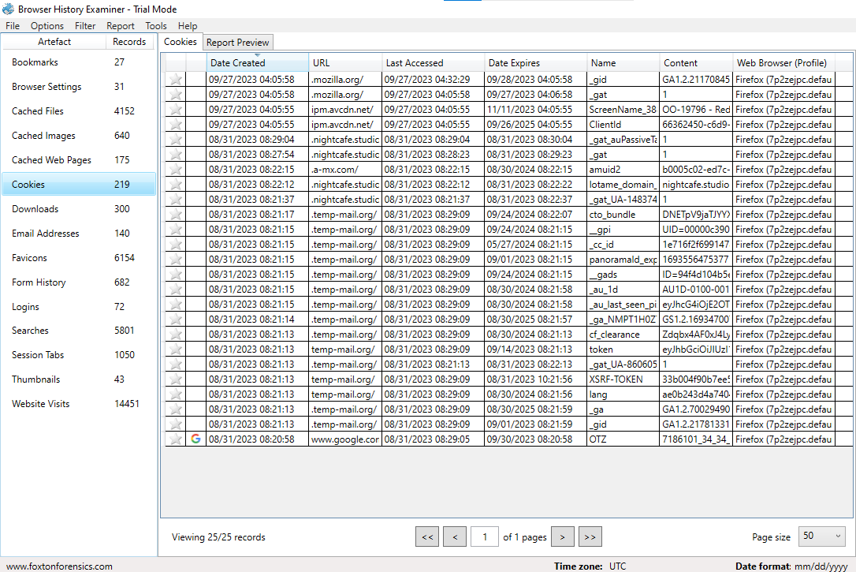

Downloads

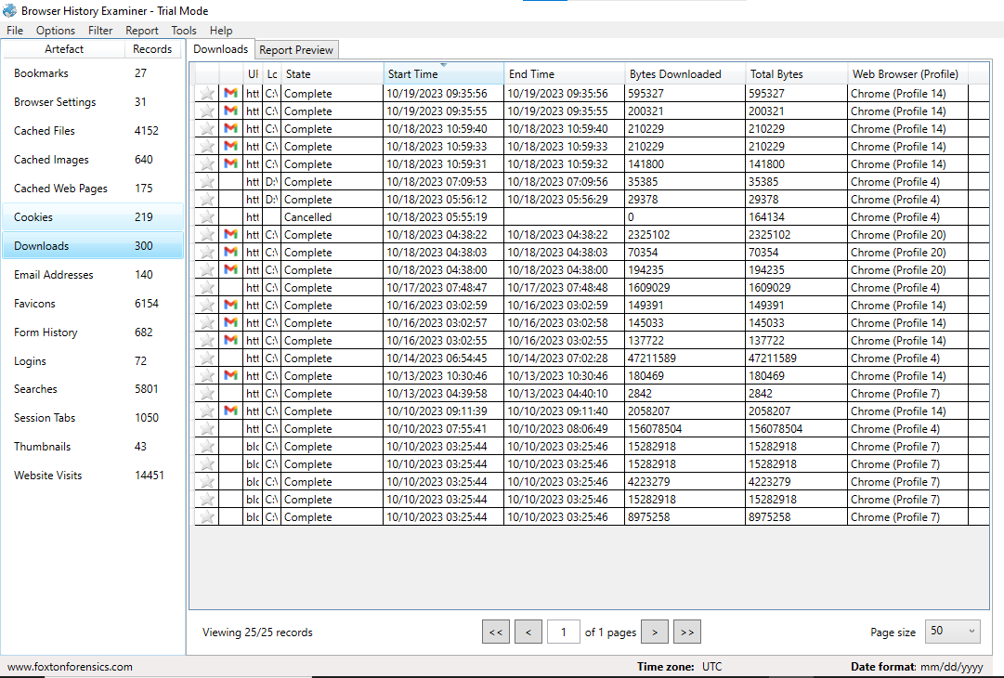

Logins

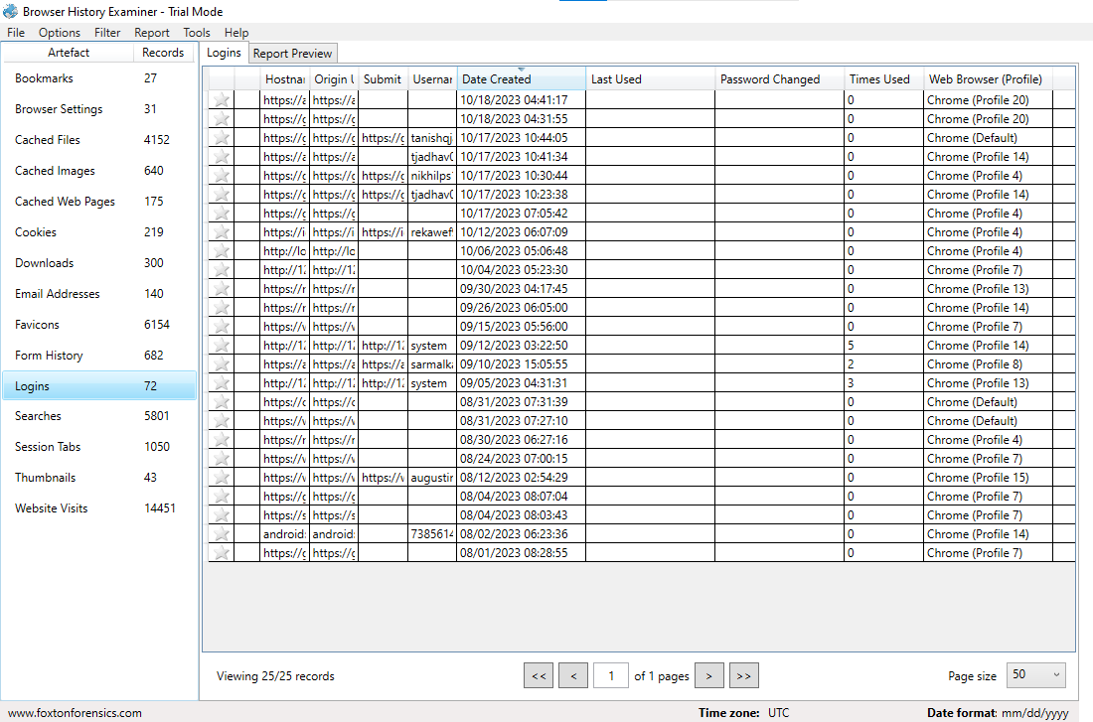

Searches

